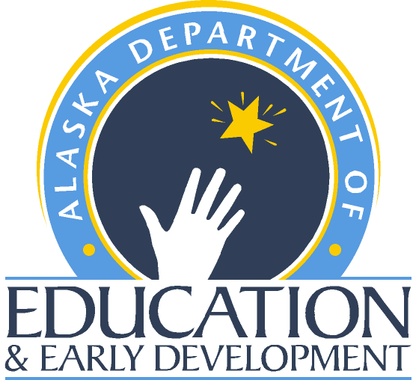 Teacher State-Approved Program Verification
  - Teacher Certification - Alaska Department of Education and Early Development

APPLICANT INFORMATION
Last Name: First Name: M.I.:
Social Security Number: Date of Birth: Gender:
- The remaining sections below are to be completed by the state approved program, NOT the applicant.

STATE-APPROVED EDUCATOR PREPARATION PROGRAM INFORMATION
Applicants who have completed a state-approved educator preparation program and have met all the associated testing requirements of the state with jurisdiction over the program are eligible for Alaska certification. A state-approved educator preparation program must include a program of study and a supervised clinical practice. To qualify for a certificate or endorsement in Alaska, applicants must be eligible to gain a comparable certificate or endorsement in the state that holds jurisdiction over the approved program. Certifications and endorsements based on testing alone cannot be used for Alaska certification.
Program Type: Indicate the type of state-approved educator preparation program:
Traditional program/University-based Non-traditional/University-based
Non-traditional/Alternative
Program Standards: Specify which standards the approved program meets:
CAEP/NCATE/TEAC State Standards Other:
Clinical Practice: Indicate the type of supervised clinical practice required by the state-approved program completed by the applicant:
Student Teaching Internship Met requirement through a state-approved alternative
Field Experience Practicum Other (Provide an explanation on a separate page)
Degree Information: Specify the degree the applicant earned as part of the approved program:
Bachelors Masters M.A.T Ed.D. Ph.D.
No degree/endorsement/certification ONLY Other:
Certificate/Endorsement Information: Indicate the certificate and/or the endorsement areas in which the applicant has completed the state-approved educator preparation or endorsement program, and met all associated testing requirements.
Certificate/Endorsement Area Grade Level(s) Date Completed

By signing below, I verify the applicant has:
- Satisfied all the requirements of the state-approved educator preparation or the endorsement program to be eligible for certification/endorsement in the areas listed above;
- Passed all the jurisdiction’s testing requirements in place at the time the applicant completed the program listed above; and
- Maintained ethical standards required of an educator while participating in the state-approved program.
Signature of Certifying Official: Printed Name Title Date

Teacher State-Approved Program Verification
  - Teacher Certification - Alaska Department of Education and Early Development

APPLICANT INFORMATION
Last Name: First Name: M.I.:
Social Security Number:

SIGNATURE
Name of College/University/State Agency City State Regional Accrediting Association

Signature of Certifying Official: Printed Name Title Date

Phone Number: Fax Number:

Email Address:

INSTITUTIONAL OR STATE STAMP OR SEAL

IF NOT AVAILABLE, FORM MUST BE SIGNED IN BLUE INK
Please return the original State-approved Program Verification to the Applicant.
Photocopies or faxes will not be accepted.

CONTACT TEACHER CERTIFICATION
If you have questions, please use the following information to contact the Teacher Education & Certification Office:
Email: Teacher Certification (tcwebmail@alaska.gov)
Phone: (907) 465-2831 Fax: (907) 465-2441
Teacher Certification Website (https:/education.alaska.gov/teachercertification)

Teacher State-Approved Program Verification
  - Teacher Certification - Alaska Department of Education and Early Development

AVAILABLE ENDORSEMENTS

ART/FINE ARTS
- Art
- Music
- Music – Choral
- Music – Instrumental
- Theater Arts
- Visual Arts

ALASKA NATIVE STUDIES
- Alaska Native Studies
- Aleut Language/Culture
- Athabascan Language/Culture
- Haida Language/Culture
- Inupiaq Language/Culture
- Tlingit Language/Culture
- Yupik Language/Culture

BUSINESS
- Business Education
- Business Communication
- Computer Education
- Marketing

EARLY CHILDHOOD
- Early Childhood Education

EDUCATIONAL TECHNOLOGY
- Distance Teaching & E-Learning
- Educational Technology

ELEMENTARY EDUCATION
- Elementary Education

LANGUAGE ARTS
- Communication
- English
- English Literature
- Humanities
- Journalism
- Language Arts
- Literature
- Russian Literature
- Speech

MATHEMATICS
- Mathematics
LIBRARY
(Only available if done through a teacher preparation program.)
- Library Science
- Media Specialist
- School Librarian

MIDDLE SCHOOL
- Middle School
- Middle School English / LA
- Middle School Math
- Middle School Science
- Middle School Social Studies

PHYSICAL EDUCATION / HEALTH
- Coaching
- Health
- Health Education
- Kinesiology
- Physical Education

READING
- Reading
- Reading Specialist
- Remedial Reading

SCIENCE
- Biology
- Chemistry
- Earth Science
- Environmental Science
- General Science
- Geology
- Life Science
- Natural Science
- Physical Science
- Physics
- Science
- Zoology

SOCIAL SCIENCES / STUDIES
- Anthropology
- Economics
- Geography
- Government
- History
- Political Science
- Psychology
- Russian History
- Social Science
- Sociology
- Social Studies
- U.S. History
- World History

SPECIAL EDUCATION
- Adaptive E.
- Cognitively Impaired
- Communication Disorders
- Emotionally Disturbed
- Hearing Impaired
- Learning Disability
- Multi-Handicapped
- Physically Handicapped
- Resource
- Special Ed – Early Childhood
- Special Education
- Visually Handicapped

VOCATIONAL EDUCATION
- Agriculture
- Family/Consumer Science
- Industrial Arts
- Industrial Technology
- Natural Resources
- Technology Education
- Vocational Education

WORLD LANGUAGES
- Bilingual Education
- Chinese
- English as a Foreign Language
- English as a Second Language
- French
- German
- Italian
- Japanese
- Latin
- Russian
- Spanish

Statewide English as a Second Language Acquisition, Bilingual and Literacy Education (SLABEL)

